# Web Analytics Minor Project Report:-

# E-commerce User Behavior Analysis Using Web Analytics

# 

**Submitted by- Submitted to-**

**Name: Muskan Devi Er. Prabhjot kaur**

**UID: 24MCI10074 Emp.Id: E17274**

**Section: 24MAM-4-A**

**Semester: 2nd**

**(MCA - AIML)**

# Table of Contents

1. **Introduction**
2. **Objectives**
3. **Outcomes**
4. **Implementation**

* **Data Collection**
* **Metrics Tracked**
* **Visualization Tools**
* **Analysis**

1. **Visual Representations (Screenshots)**

* **Google Analytics Dashboard**
* **Bounce Rate and Page Views**
* **Heatmaps**
* **Funnel Analysis**

1. **Future Scope**
2. **References and Bibliography**

# Objectives of the Project:

* Analyze user behavior patterns on an e-commerce website using web analytics tools.
* Identify high-performing pages that drive engagement and sales.
* Detect underperforming pages with high bounce or exit rates.
* Track the complete user journey from landing to conversion.
* Optimize the conversion funnel by understanding drop-off points.
* Utilize heatmaps and click-tracking to assess user interaction.
* Generate actionable insights using visual dashboards and data interpretation.
* Improve overall website performance to enhance user experience and retention.

# Outcomes:

* Gained a clear understanding of how users interact with different sections of the website.
* Identified key pages with high bounce and exit rates for targeted improvements.
* Revealed navigation patterns and common drop-off points through user flow analysis.
* Improved strategies for increasing user engagement, retention, and conversions.
* Developed visual dashboards to monitor traffic, behaviour, and performance trends.
* Provided data-driven insights for optimizing the e-commerce website's layout and functionality.

# Introduction:

In today’s digital economy, e-commerce websites serve as a crucial platform for businesses to connect with customers and drive sales. With every click, scroll, and interaction, users generate valuable data that can reveal powerful insights into their behaviour.

This project focuses on analyzing user behaviour on a mock e-commerce website using web analytics tools such as Google Analytics and Hotjar. The aim is to understand how users navigate through the website, which pages attract the most attention, and where users tend to drop off without converting.

By tracking key metrics such as page views, bounce rates, session durations, and conversion rates, this study aims to uncover patterns and identify opportunities for website optimization. Visual tools like heatmaps and funnel analyses further assist in illustrating user journeys and engagement levels.

The ultimate goal is to leverage this data to improve the user experience, enhance site performance, and boost overall conversion rates.

# Implementation:

1. **Data Collection**  
To gather user behavior data, two leading analytics tools—**Google Analytics** and **Hotjar**—were implemented on the e-commerce website. Data was collected over a 30-day period, capturing real-time user interactions across various pages and features. Google Analytics provided quantitative insights, while Hotjar offered visual insights like heatmaps and session recordings for qualitative analysis.

2. **Metrics Tracked**  
A comprehensive set of performance and engagement metrics were monitored to understand user interaction and site efficiency:

* **Page Views**: To determine the popularity of individual pages.
* **Bounce Rate**: To identify pages where users leave without interaction.
* **Average Session Duration**: To measure user engagement time.
* **Conversion Rate**: To track how many users completed desired actions (e.g., purchases).
* **Click Heatmaps**: To visually represent where users click most on a page, revealing attention areas and dead zones.

3. **Visualization Tools**  
**Google Looker Studio** (formerly Google Data Studio) was used to convert raw data into interactive and visually appealing dashboards. These visualizations made it easier to identify trends, track KPIs, and present findings in an understandable format.

4. **Analysis**  
The collected data was analyzed from multiple perspectives to identify strengths and areas for improvement:

* **Product Page Engagement**: Pages with the highest and lowest user engagement were compared to identify what influences performance.
* **User Flow Diagrams**: These were created to map user navigation paths, helping to understand how users move through the site.
* **Funnel Analysis**: Detailed tracking from landing page to checkout revealed where users drop off in the purchasing process, enabling targeted funnel optimization.

**Screenshots:**

1: Page Views Chart

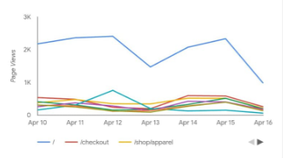

2: Bounce Rate Chart

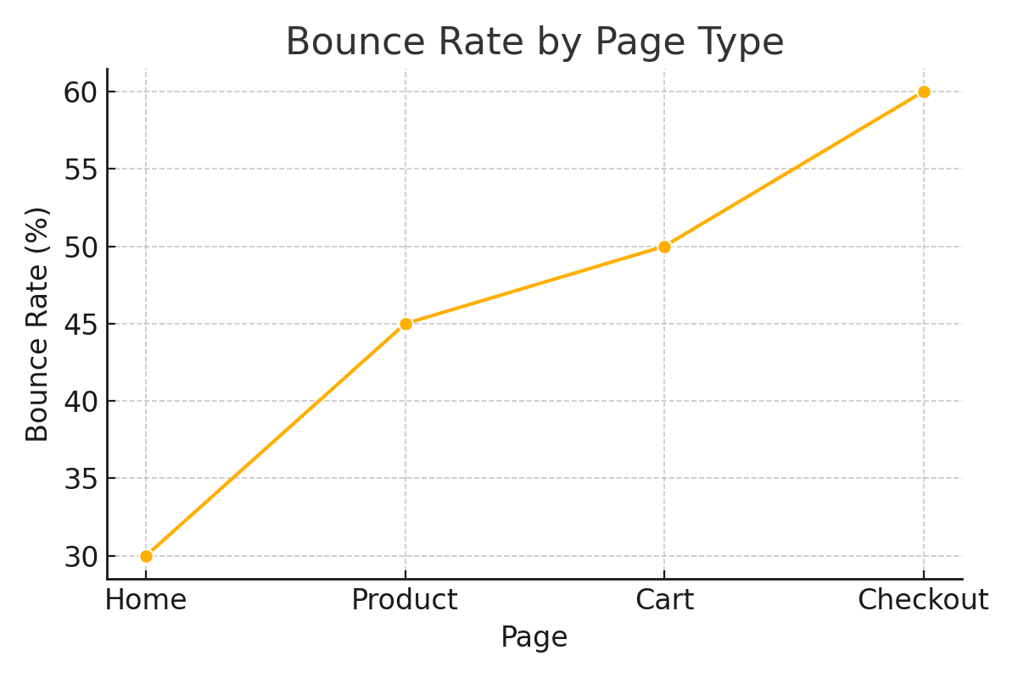

3: Google Analytics Dashboard

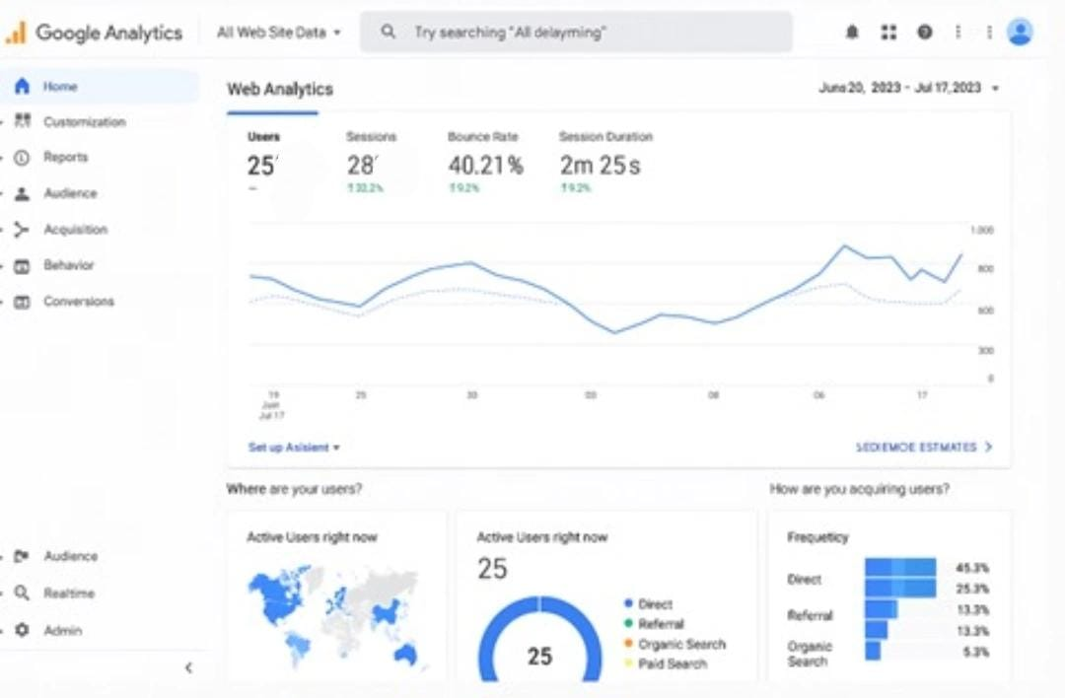

4: User Click Heatmap

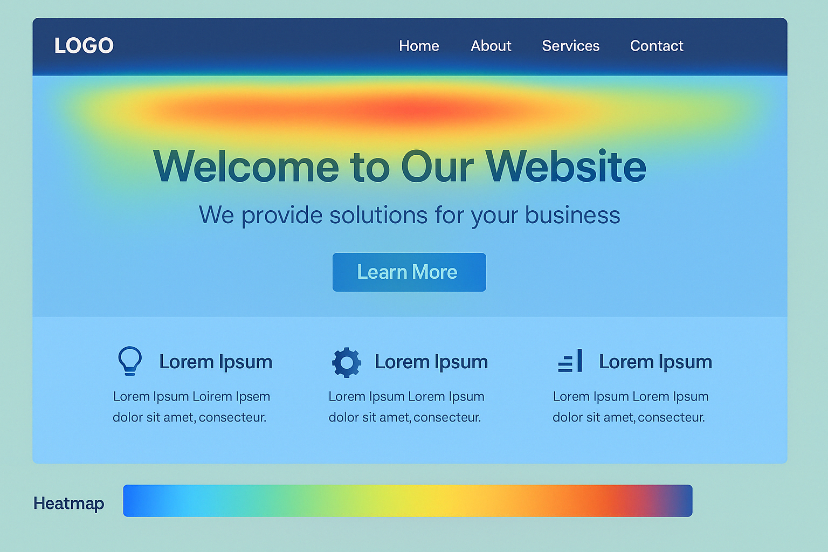

5: Funnel Analysis Visualization

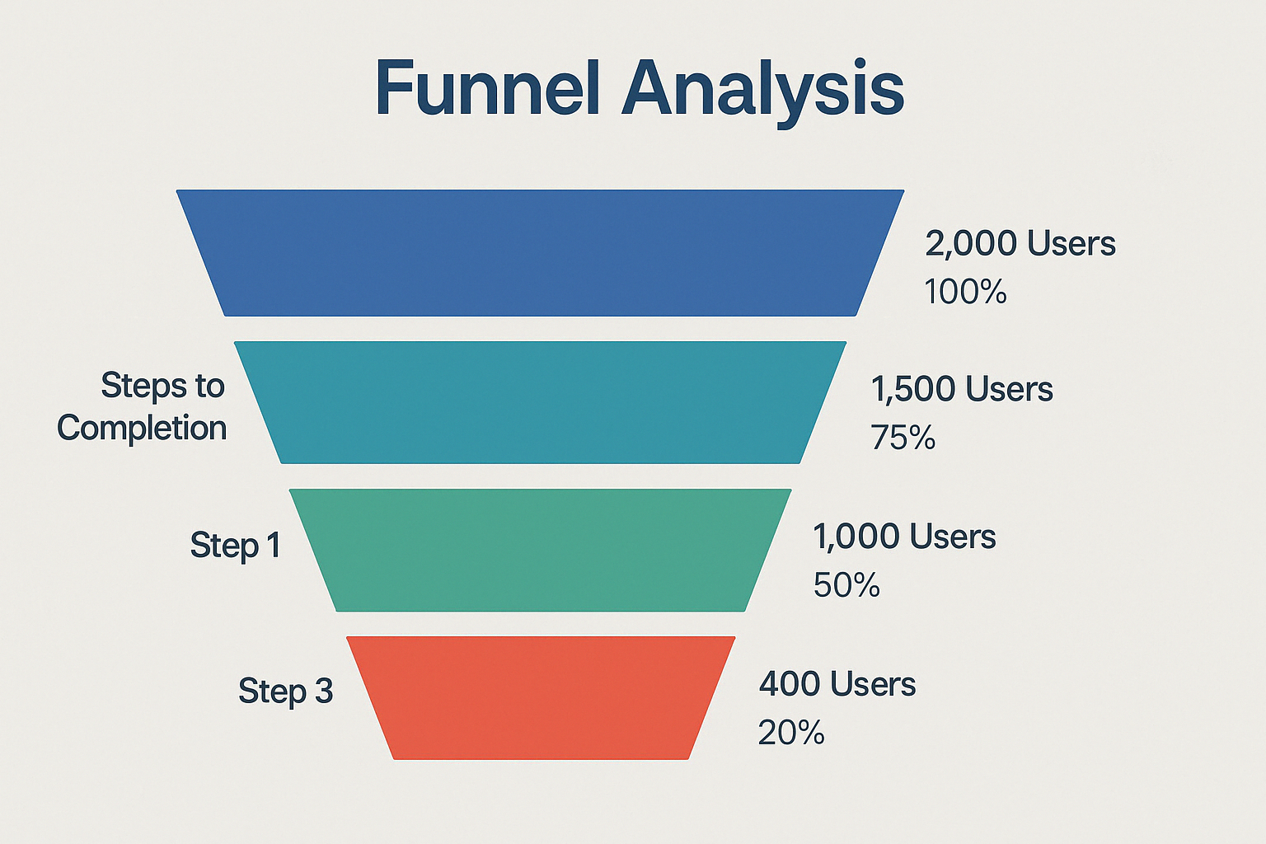

6. Top Traffic Sources

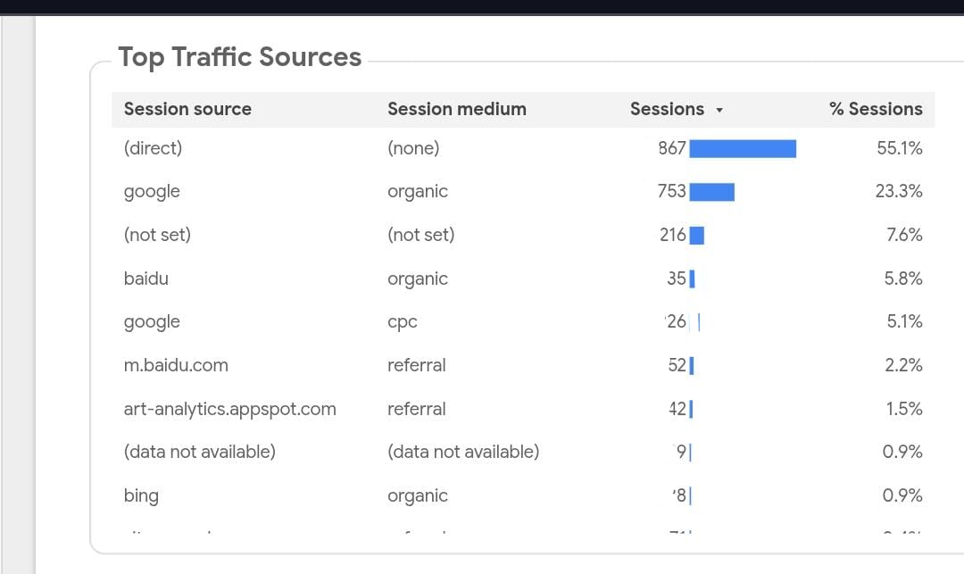

7. Event Count

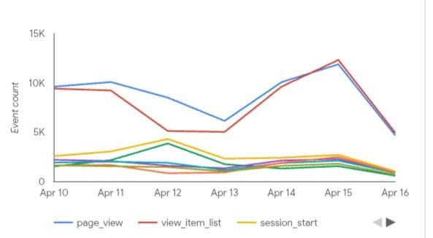

8. Browser uses

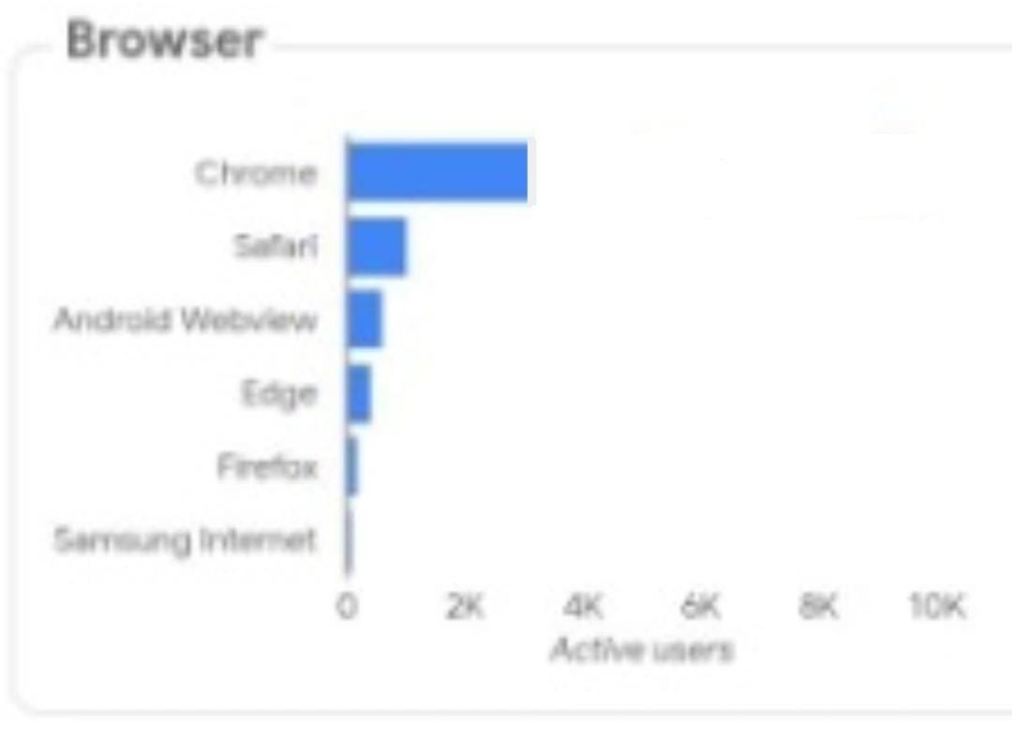

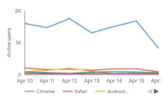

# Future Scope of Project:

* **Integration of AI-Powered Predictive Analytics**  
  Use artificial intelligence to forecast user behavior trends, such as predicting potential drop-offs or identifying users likely to convert, enabling proactive strategy development.
* **Advanced User Segmentation**  
  Apply machine learning models to categorize users based on behavior, preferences, demographics, and purchase history to deliver more personalized website experiences.
* **Real-Time Analytics Implementation**  
  Incorporate real-time tracking to monitor live user activity and respond instantly with personalized recommendations, promotional offers, or support interventions.
* **A/B Testing for Design Optimization**  
  Conduct structured A/B tests to experiment with different layouts, CTA placements, and content formats to determine the most effective website design for conversions.
* **Enhanced Funnel Visualization**  
  Build more detailed and dynamic funnel charts that adapt to user behavior over time, providing deeper insights into where and why users abandon the conversion path.
* **Voice and Mobile Interaction Analytics**  
  Extend analytics tracking to include mobile gestures and voice-based searches as more users interact with websites via smartphones and voice assistants.
* **Cross-Platform Behavior Analysis**  
  Track users across multiple devices and sessions to build a unified view of the customer journey, allowing for more consistent and optimized user experiences.

# References or Bibliography:

* Google Analytics: <https://support.google.com/analytics>

A detailed resource offering insights on implementing and utilizing Google Analytics to track and analyze website traffic and user behavior.

* Hotjar: <https://www.hotjar.com>

A behavior analytics tool that provides heatmaps, session recordings, and user feedback to improve user experience.

* Google looker Studio: <https://lookerstudio.google.com>

A data visualization platform that enables the creation of interactive reports and dashboards from multiple data sources.

Top of Form

Bottom of Form

* **GitHub Link:**